Proceedings of the 1st International Conference in Applied Engineering Science and Technological (ICAEST-I)
Sohag University- Sohag- Egypt - October1-3, 2019
Paper No. HTFF

First Name Last (Surname) Name¹, First Name Last (Surname) Name² and First Name Last (Surname) name^{3*}
¹Department/Research Institute, University, Country
²Department/Research Institute, University, Country, presenting author
^{3*}Department/Research Institute, University, Country, email presenting author

Extended Abstract
The abstract should be sent via e-mail to abstract@techedu.sohag.edu.eg, or : mahmoudsalem.ahmed@yahoo.com, mahmoud_hussien@techedu.sohag.edu.eg before the deadline.
Kindly follow this template to prepare the abstract. It should be limited to 1 page (submit only in pdf format).
The e-mail’s Subject should include the topic and type (oral or poster) of work you wish to present in the following format: (Session-Topic-Oral/Poster).
Example.Addres of paper-Oral or poster
The abstracts will be peer reviewed and the notification will be sent within 10 days of the receipt of the abstract. We encourage you to submit your abstract at the earliest and plan your travel in advance.
INTRODUCTION
The introduction should be simple and graspable to colleagues from other fields also. Please mention the novelty of the work and possible application in the introduction. References must be added in the text with superscripts[1].
EXPERIMENTAL/THEORETICAL STUDY
The specific techniques or procedure used in conducting this study can be explained briefly here.
RESULTS AND DISCUSSION
In this section, try to present the data as concisely and clearly as possible. Figures, Tables and Scheme can be included.
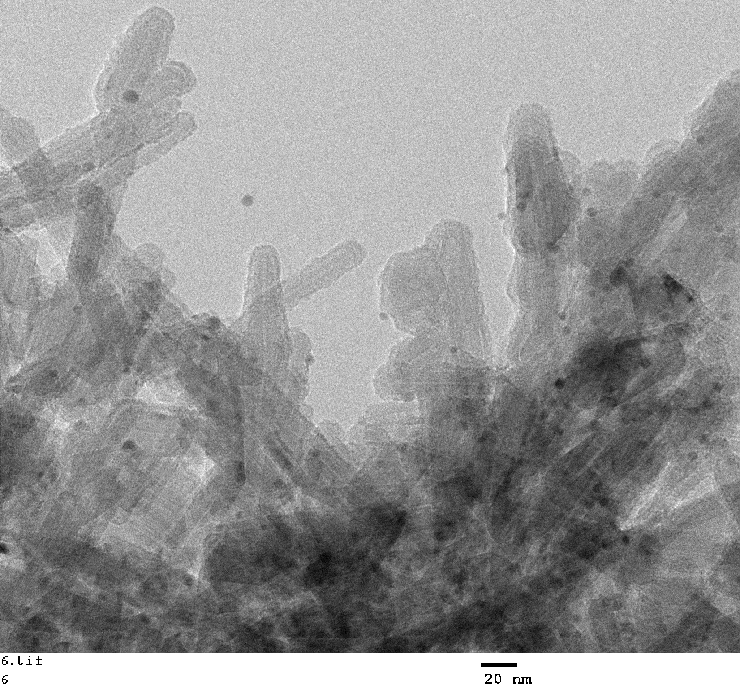
Fig. 1 TEM image of nickel doped one dimensional graphene
Discussion should summarize the observations and attempts to place this data into the context of the existing body of literature to express opinions about the significance of the work.
CONCLUSION
This short section is to summarize the work based on the facts in evidence and point out the main areas covered in the writing. It may also contain the future directions of the work in one sentence.
REFERENCES
References must be numbered. Keep the same style.
[1]. S. Pinto et. al, Appl. Phys. Lett.(2018)101, 12-20.
ACKNOWLEDGMENTS
Authors can acknowledge any person, or funding agency that has made a significant contribution to the work.

